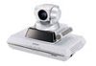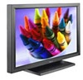

Sony PCS-1P

Pioneer PDP-50MXE1

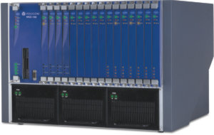

**MCU MGC-50/100**